ROUGH GUIDE TO UCAS!

CONTENTS

Description | Page Number
Important deadlines | 2
BMAT – Medical and Dentistry Test | 3
UKCAT – UK Clinical Aptitude Test | 4
LNAT – National Admissions Test for Law | 5
Other Admissions Tests | 5
Types of degrees | 6
What is Apply? | 7
Registration for Apply11 | 7
First log in screens | 14
Personal details | 18
Additional Information | 20
Choices | 21
Education | 23
Employment | 26
Personal Statement | 27
Reference | 28
Payment | 28
UCAS TV | 29
Compact Applications | 30
Progression Agreements | 35
UCAS Tariff Points | 36
UCAS Contact Details | 37
Student Services Staff Contact Details | 37
HE Finance | 37
Open Days | 38

UCAS 2011
INFORMATION FOR STUDENTS
IMPORTANT DEADLINES

7th July 2010 | Futures Day. You should have already been drafting your Personal Statement during the Summer Term, registered on APPLY11 and started your UCAS application.
16th July 2010 | All students to have started an on-line application to UCAS. Even if you are not intending to go to university, the UCAS application is a good example of an on-line application form.
After 19th August 2010 | Add your AS final results to your UCAS application and also add your A2 subjects – leaving the grades ‘pending’
17th September 2010 | Deadline for Student Services to receive UCAS applications if you are applying for Oxbridge, Medical, Dentistry or Veterinary courses. You must have been through your application with your tutor and brought the lilac Tutor Final Checklist (completed and signed by your tutor) to Student Services by this date to ensure your application is processed and submitted in time for the UCAS deadline of 15th October 2010.
7th October 2010 | Deadline for Student Services to receive all UCAS applications if you are applying to a Russell Group or highly selective university. You must have been through your application with your tutor and brought the lilac Tutor Final Checklist (completed and signed by your tutor) to Student Services by this date to ensure your application is processed and submitted in time for the UCAS deadline of 15th January 2011.
12th November 2010 | Deadline for Student Services to receive all other UCAS applications. You must have been through your application with your tutor and brought the lilac Tutor Final Checklist (completed and signed by your tutor) to Student Services by this date to ensure your application is processed and submitted in time for the UCAS deadline of 15th January 2011.
14th January 2011 | UCAS deadline. Student Services will guarantee submitting your application to UCAS to meet this deadline if you get your lilac Tutor Final Checklist (completed and signed by your tutor) and paper copy of your application to Student Services by 12th November 2010.  Applications can be submitted to UCAS after 15th January 2011 but they will be considered as ‘late applications’. Some courses may be closed by Universities at this point whilst they check their numbers. (These courses may be opened again at a later date). Universities may still consider these applications if they want to make more offers.
15th January 2011 or 24th March 2011 | (Art & Design Courses) UCAS deadline. You can submit up to 5 choices for Art & Design courses. It is important that you check the closing date for the individual course as it may be either 15th January or 24th March.
30th June 2011 | Applications received by UCAS after this date are entered into Clearing.

Don’t leave your application to the last minute – the sooner you complete it and pass it to Student Services for processing, the earlier we can submit it and the better chance you have of getting a university place!
We will aim to process applications within 10 working days of receiving all completed paperwork in Student Services.
DEADLINES FOR MEDICAL AND DENTISTRY TESTS

BMAT – BioMedical Admissions Test
www.bmat.org.uk

The following Institutions and Courses require you to take the BMAT:

Courses Requiring BMAT
University of Cambridge (C05)
A100 Medicine
A101 Graduate Course in Medicine (not essential)
D100 Veterinary Medicine
Imperial College London (I50)
A100 Medicine
B900 Biomedical Science (3 year course)
BB29 Pharmacology and Translational Medical Science
BB2X Pharmacology and Translational Medical Science with a year in industry
University of Oxford (O33)
A100 Medicine
B100 Physiological Sciences
Royal Veterinary College (R84)
D100 Veterinary Medicine
D101 Combined Degree Programme
UCL (U80)
A100 Medicine

Entries start | Wednesday 1st September 2010
Closing date for requests for special versions of question papers (e.g. Braille or enlarged) | Friday 17th September 2010
Standard entry closing date | Thursday 30th September 2010
Late entry closing date (subject to penalty fees) | Friday 15th October 2010
Test date | Wednesday 3rd November 2010
Results release date | Wednesday 24th November 2010

UKCAT – UK Clinical Aptitude Test
www.ukcat.ac.uk/home

The following Institutions and Courses require you to take the UKCAT:

University | UCAS Course Code
University of Aberdeen | A100, A201
Brighton and Sussex Medical School | A100
Barts and The London School of Medicine and Dentistry | A100, A101, A200, A201
Cardiff University | A100, A104, A200, A204
University of Dundee | A100, A104, A200, A204
University of Durham | A100
University of East Anglia | A100, A104
University of Edinburgh | A100
University of Glasgow | A100, A200
Hull York Medical School | A100
Keele University | A100, A104
King's College London | A100, A101, A102, A103, A202, A203, A205
Imperial College London Graduate Entry | A101
University of Leeds | A100
University of Leicester | A100, A101
University of Manchester | A104, A106, A204, A206
University of Newcastle | A100, A101, A206
University of Nottingham | A100
University of Oxford Graduate Entry | A101
Peninsula College of Medicine and Dentistry | A100
Queen's University Belfast | A100, A200
University of Sheffield | A100, A104, A200
University of Southampton | A100, A101, A102
University of St Andrews | A100, B900
St George's, University of London | A100
Warwick University Graduate Entry | A101

Key Dates and Information

UKCAT registration opens | 4 May 2010
UKCAT testing begins | 6 July 2010
Bursary and voucher application deadline | 27 September 2010
UKCAT registration deadline | 27 September 2010
UKCAT last testing date | 8 October 2010

LNAT – NATIONAL ADMISSIONS TEST FOR LAW
www.lnat.ac.uk

The following universities required students to sit the LNAT test for 2010 entry. More institutions may sign up for entry in 2011 so it is important that you check with the university that you are interested in to see if this is an entry requirement.

University of Birmingham
University of Bristol
Durham University
University of Exeter
University of Glasgow
University of Leeds
King's College London
University of Nottingham
University of Oxford
University College London

The LNAT is an on-screen test including multiple-choice questions and essay questions. To help students prepare practice tests are available – log on to www.lnat.ac.uk

Students choose a date to take the LNAT at a test centre near their home or college. Testing for 2010-11 begins in early September 2010.

Watch out for university-specific deadlines!

OTHER ADMISSIONS TESTS TO BE AWARE OF

ELAT English Literature Admissions Test (Required by Oxford)
HAT History Aptitude Test (Required by Oxford)
MAT Mathematics Aptitude Test (Required by Oxford)
MML Modern & Medieval Languages Test (Required by Cambridge)
PAT Physics Aptitude Test (Required by Oxford)
STEP Sixth Term Examination Papers (Required by Cambridge)
TSA Thinking Skills Assessment (Required by Oxbridge & UCL)

The above Admissions Tests are required for certain courses at the universities specified.

Please make sure you check to see if your chosen course requires an Admissions Test.

Some of the Tests are taken at the University, some are taken here at College. Some charge a fee and others are free.
TYPES OF DEGREES

Single Honours | One subject only
Joint Honours | Two subjects – an equal time spent on both
Combined Honours | Two or more subjects – the proportion of each may vary
Modular | A wide range of choice and flexibility
Sandwich | This will include an organised period of time spent in industry or abroad
Foundation Degree | 2 years – 2/3rds of a full degree. Normally vocational
Higher National Diploma (HND) | 2 years – 2/3rds of a full degree. Normally vocational.
Top-Up | 1 or 2 years to complete a degree from a Foundation Degree or HND. You would need to discuss with the institution which year of the degree programme you are eligible to go on.
Work Based | The entry requirements may stipulate that you should have been in employment for a length of time and you may also need a letter from your employer.

WHAT IS APPLY?

APPLY is an application system that allows you to apply online for full-time undergraduate courses at universities and colleges. UCAS ask you to complete the following sections.

- Registration
- Personal details
- Additional information (UK applicants only)
- Choices
- Education
- Employment
- Personal Statement
- Reference – this is added by Barton Peveril
- Declaration
- Pay and send

Your application does not have to be completed all at once. The system allows you to leave a section partially completed so you can return to it later and change any information you have entered.

REGISTRATION

UCAS need to know your personal details, such as your name, address and date of birth. They also ask you to read and accept the terms and conditions for using Apply. The registration progress generates your username and you create your own password which you use to login to Apply.

**You must make a note of your username and password when registration is complete**

A quick guide to registration:

- Log on to www.ucas.com

- Click on APPLY

- Click on Register/Log in to use APPLY 2011 (do not select APPLY 2010)

- Student should read terms and conditions

- Select registering through school or college

- Type in the buzzword BARTPEV11

- Follow instructions to register personal details (i.e. name, address, telephone number, e-mail address etc)

- Choose a password and enter a security question and answer (can be used as a prompt in the event that student forgets login details)

- Click SEND to create and issue a username – YOU MUST NOTE THESE DETAILS!
The following screen prints show you what you will see during the UCAS Registration process:
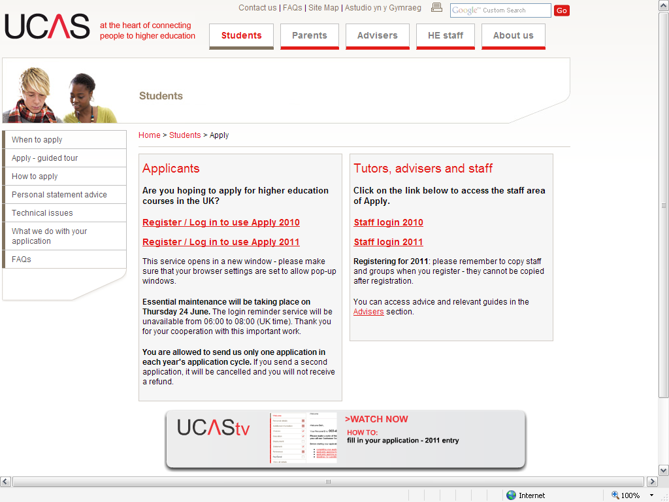

PLEASE ENSURE YOU SELECT
‘REGISTER/LOG IN TO USE APPLY 2011
(DO NOT CHOOSE 2010)

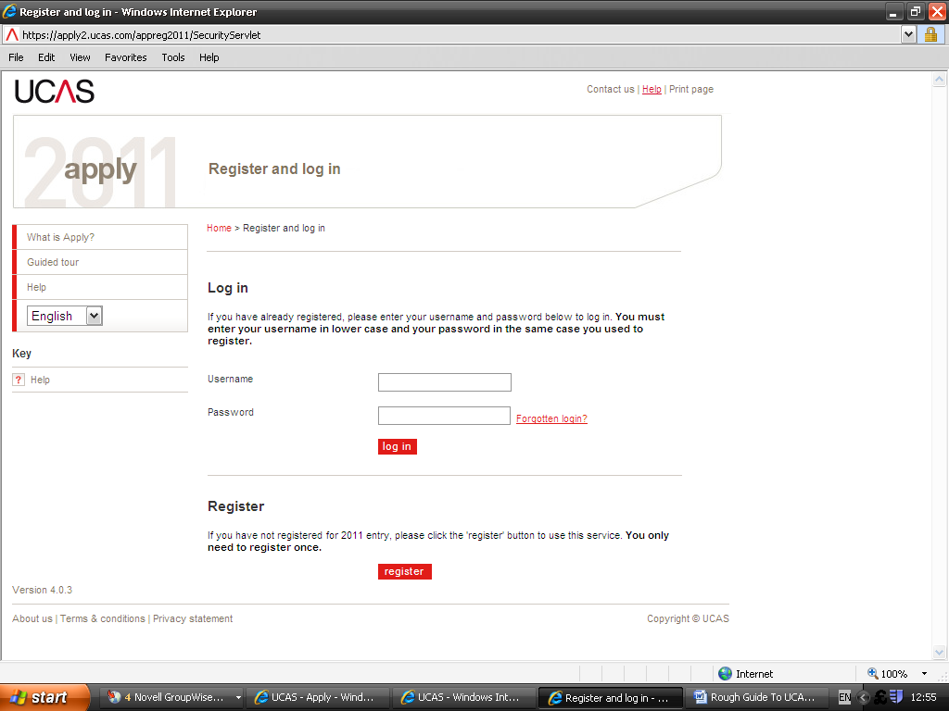

First you need to Register – click on the ‘register’ button

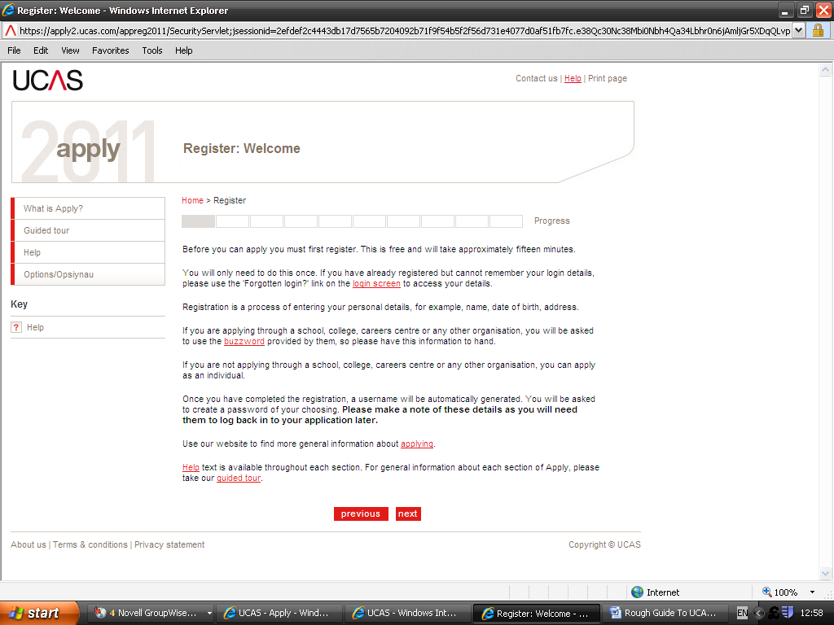

Read through the instructions and then press ‘next’

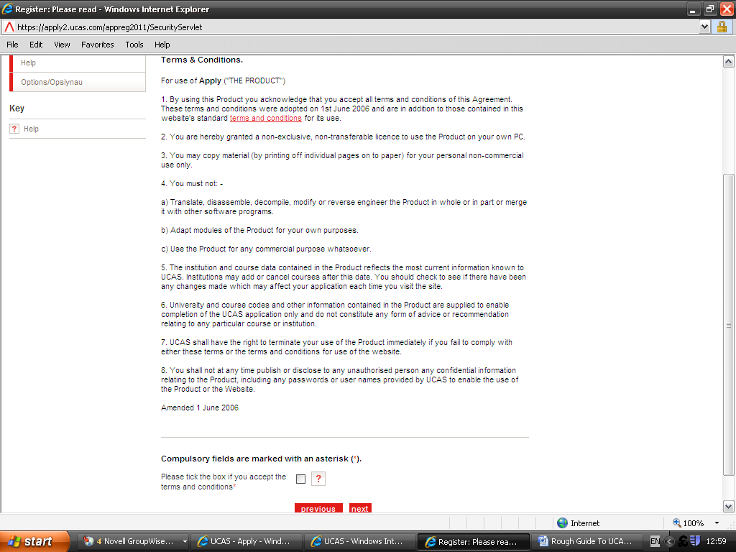

Read the terms and conditions, then tick the box to accept, before pressing ‘next’

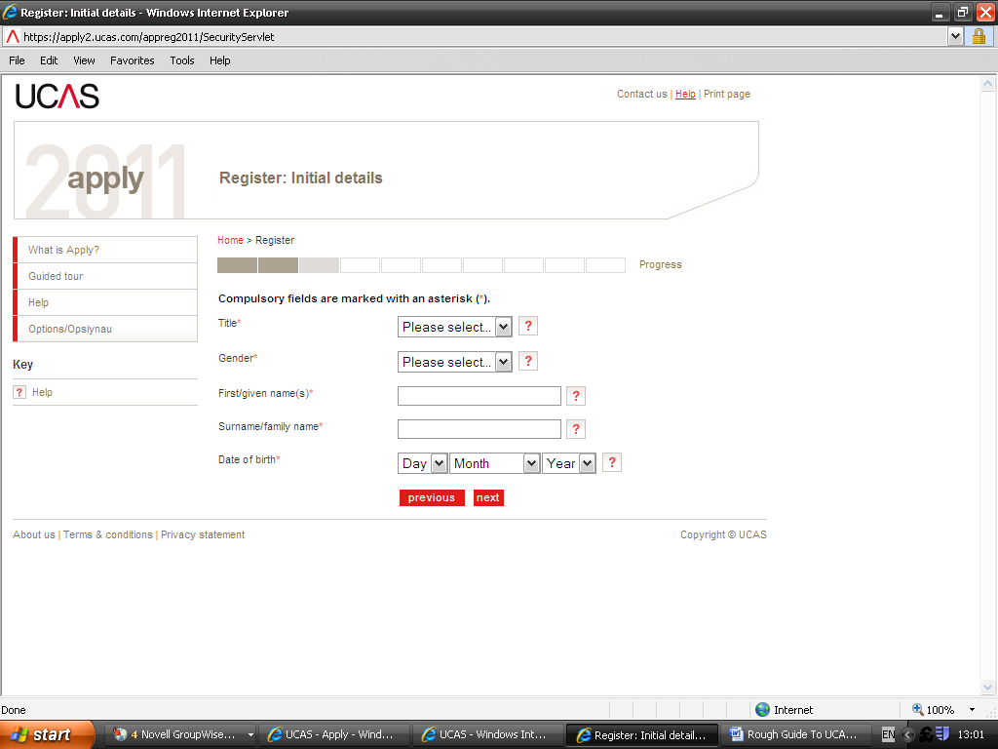

Complete each field on the screen before pressing ‘next’

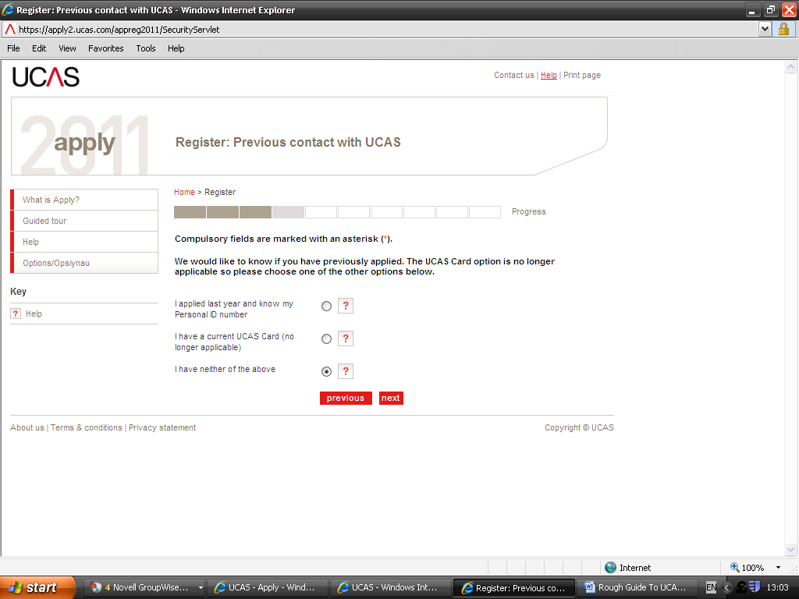

Select the option as shown above and then press ‘next’

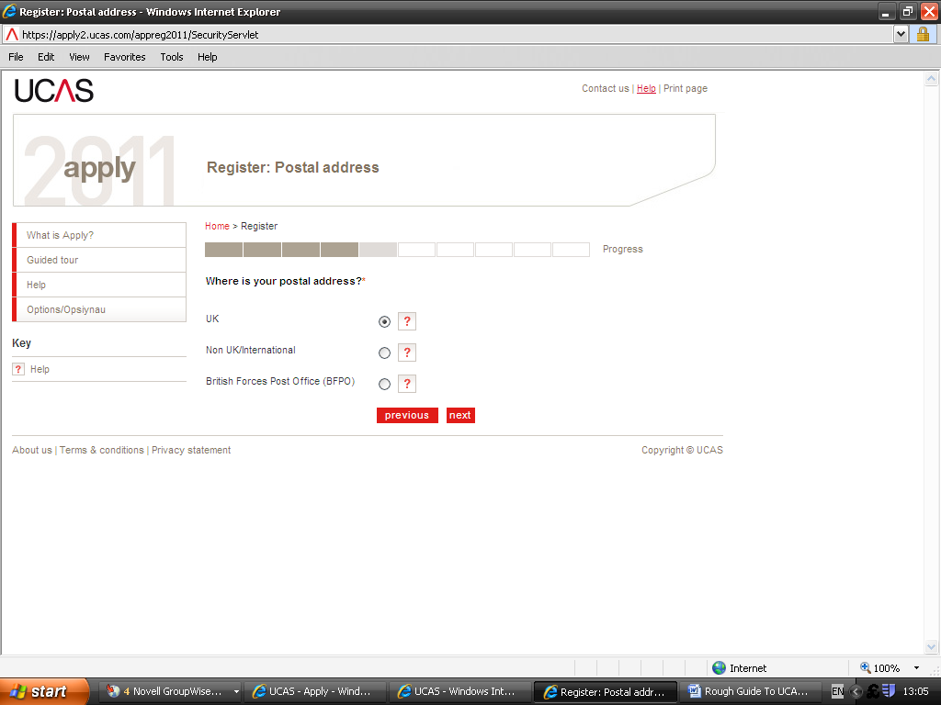

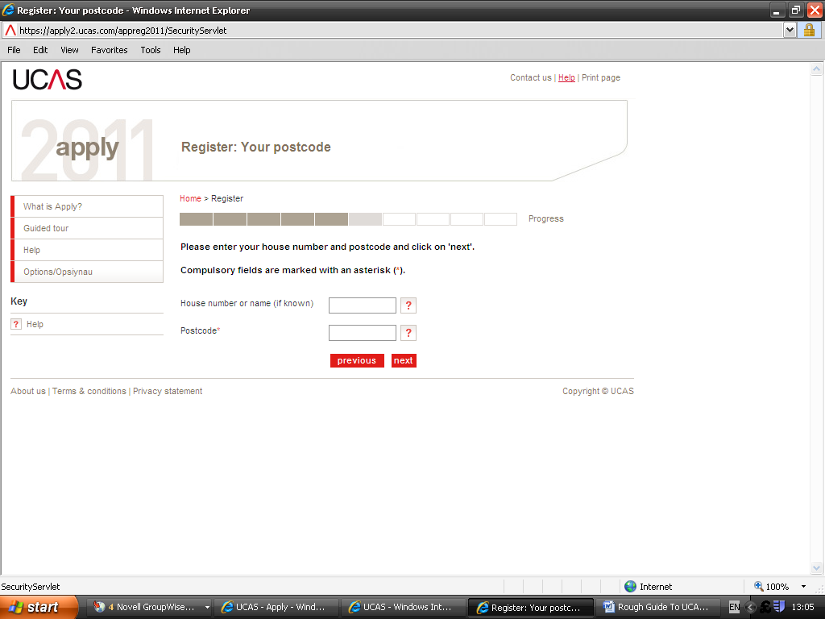

Address confirmation screen will then appear – press ‘next’ if correct.

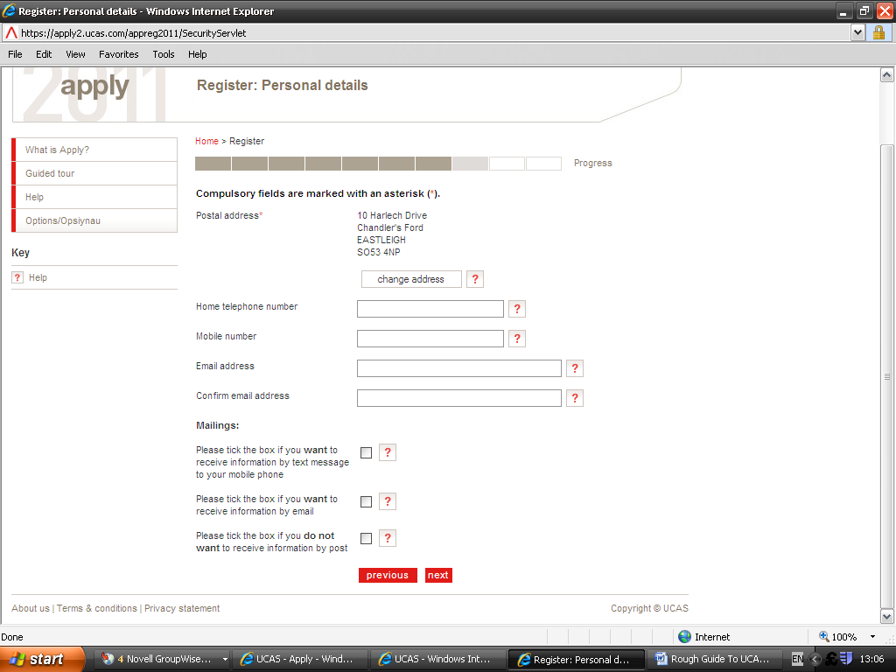
Your address shown here
Enter your College e-mail address.

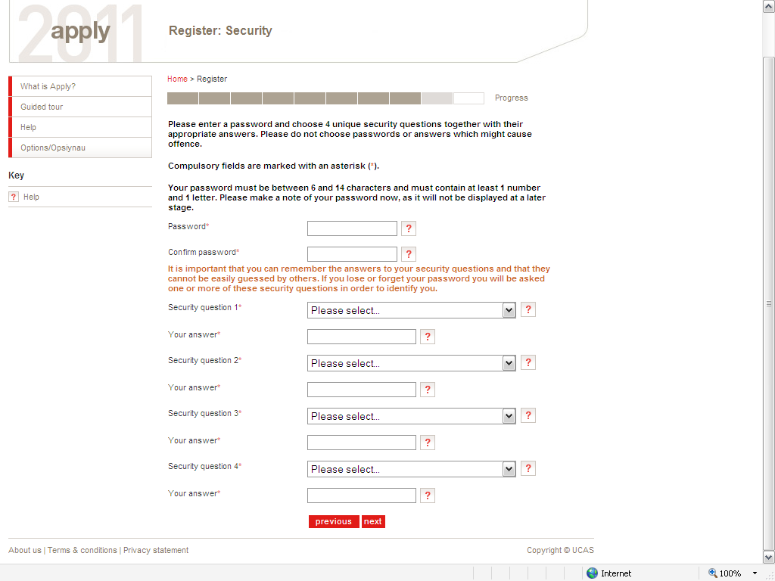
Write down your password and keep it safe!

Make sure that you remember your security questions and answers! You may need them later on.

MAKE A NOTE OF YOUR PASSWORD!!

Student Services Staff will not be able to retrieve it if you lose it!

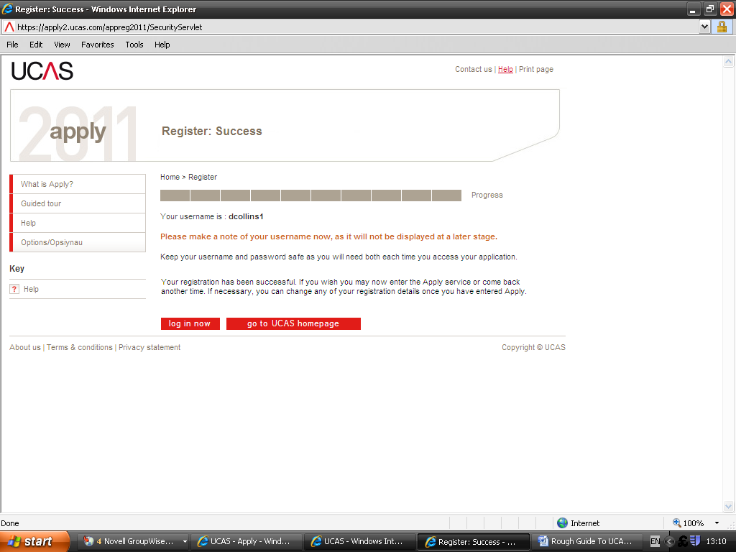
Write down your username and keep it safe!

YOU MUST MAKE A NOTE OF YOUR USERNAME AS IT WILL NOT BE DISPLAYED AGAIN.

Student Services staff will NOT be able to retrieve it if you lose it!

YOU WILL NEED YOUR USERNAME AND PASSWORD EACH TIME YOU LOG IN TO ACCESS YOUR APPLICATION.

FIRST LOG IN SCREENS

The following screens will only need to be completed the first time you log into APPLY10.

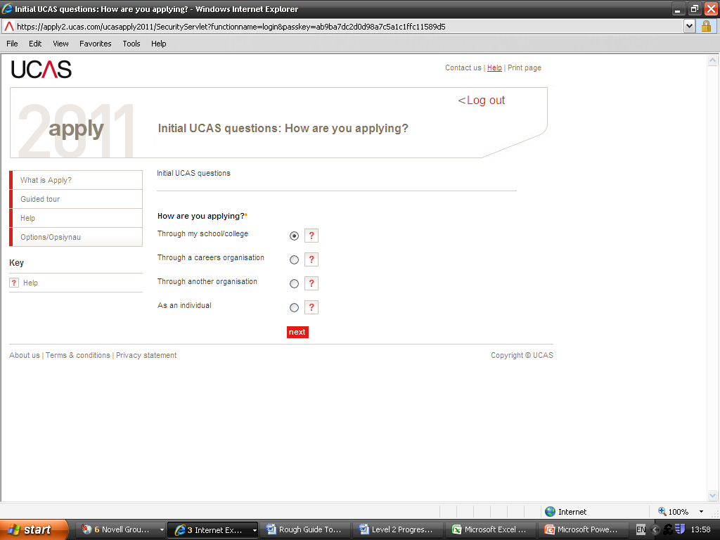
You will be applying through your school/college

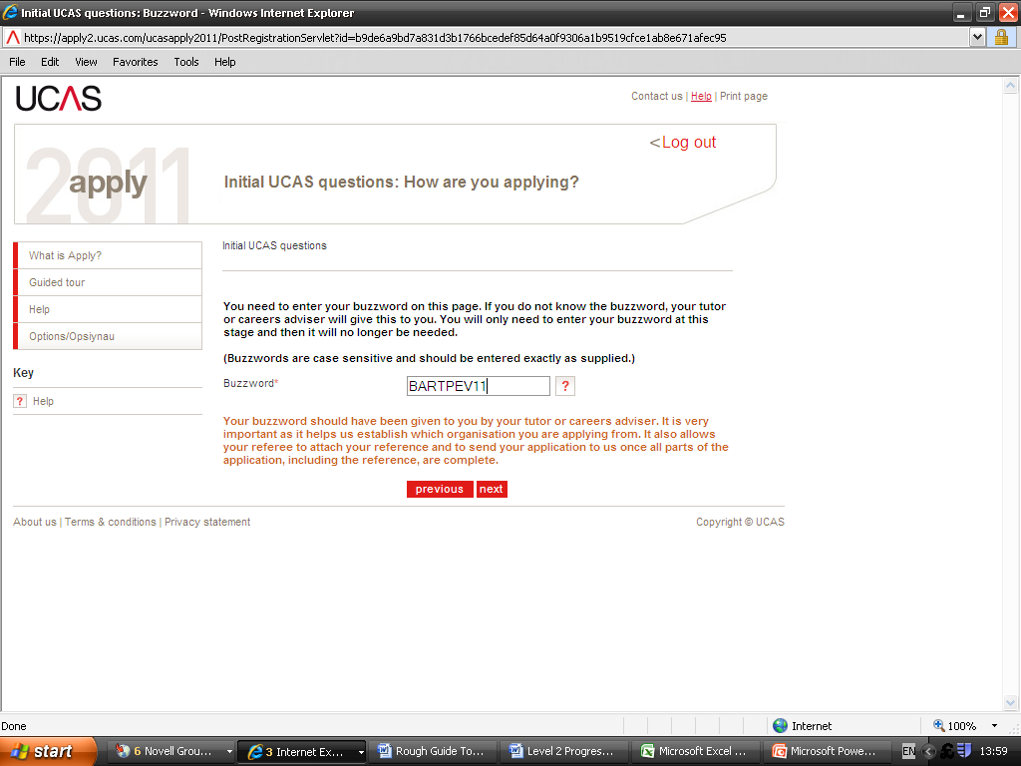

The Buzzword for APPLY11 is BARTPEV11

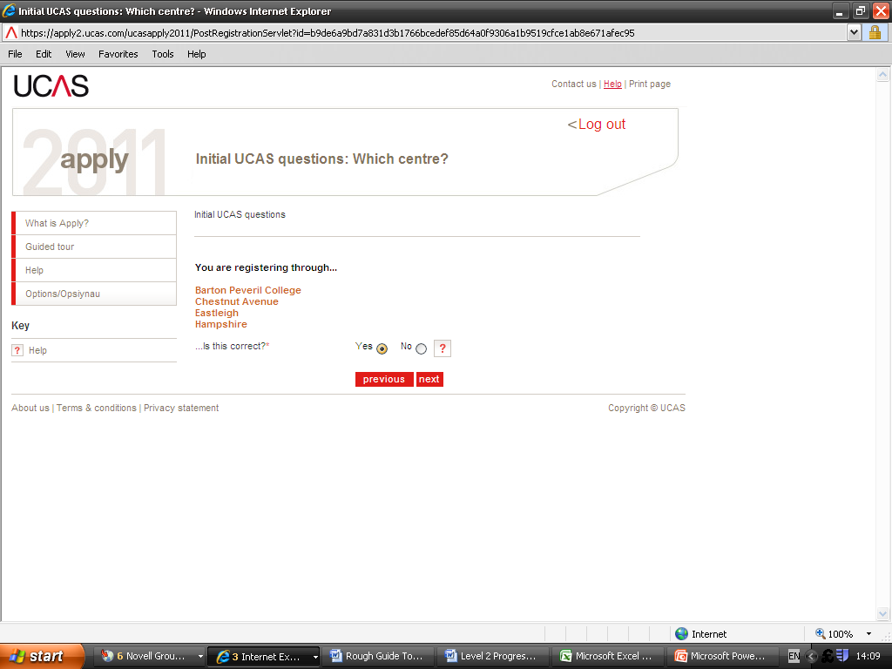

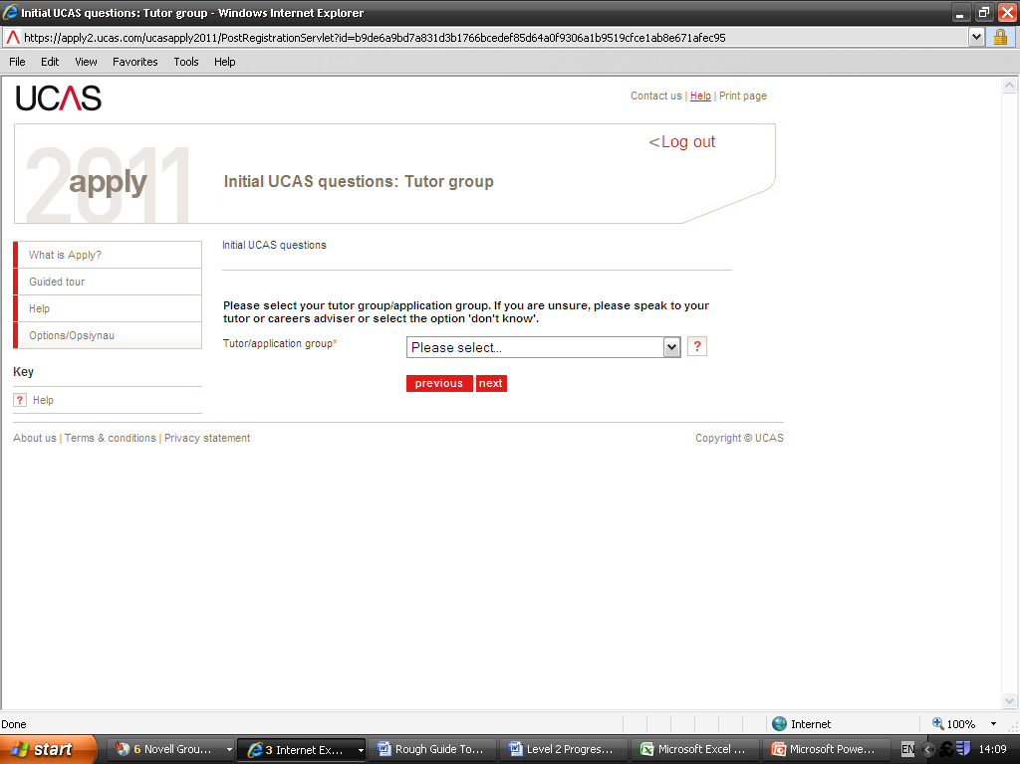
Please ensure you select your correct tutor group by using the drop down arrow.

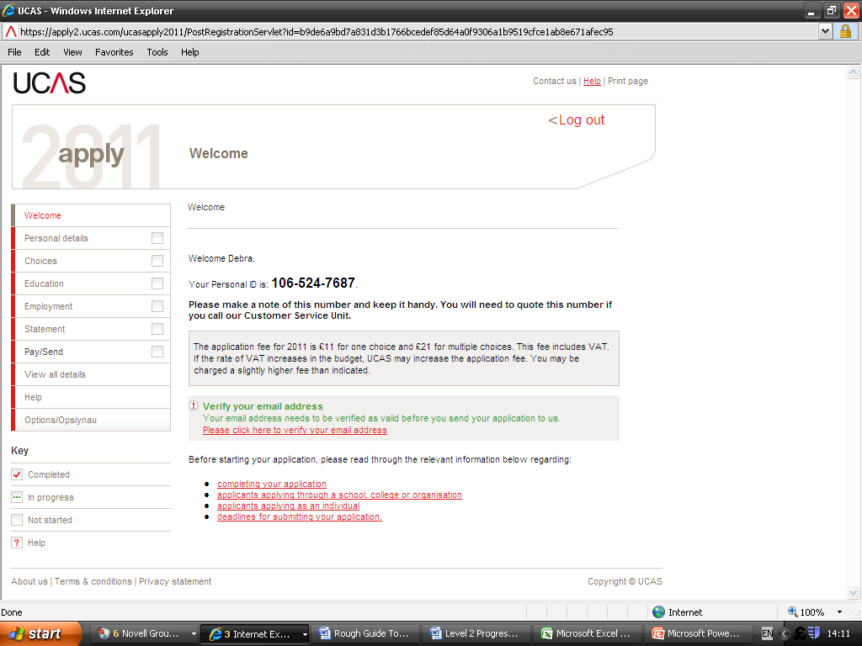
Make a note of your Personal ID and keep it safe. You will need it if you need to contact UCAS with any queries.

Click on the red ‘click here to verify your email address’. An e-mail will be sent by UCAS to the e-mail address you registered in your personal details (this should have been your College e-mail address). Check your in-box and retrieve this e-mail from UCAS to get your verification code.

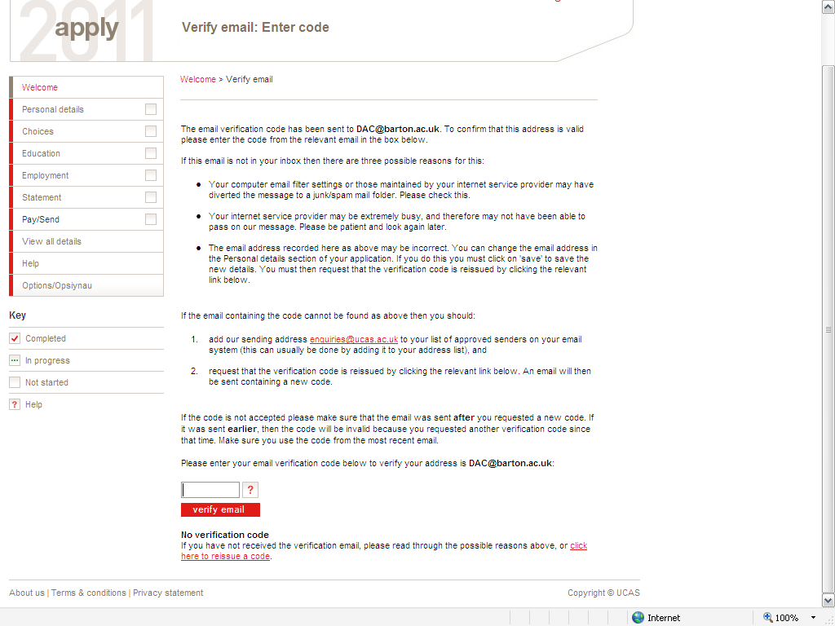

Scroll down and type in the verification code specified in the e-mail sent by UCAS

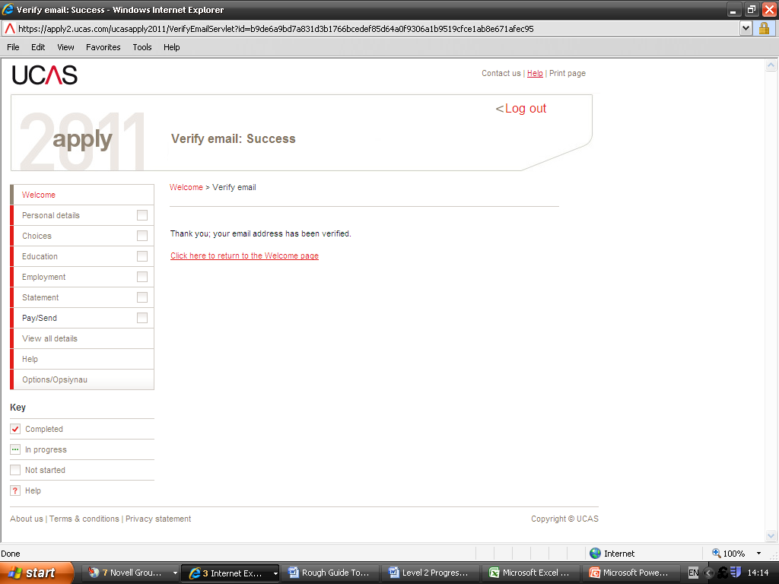

This is the final screen and you are now able to go to the Welcome Page and begin to fill in your application form.
PERSONAL DETAILS

Some of this section will be filled in automatically with the details you entered during registration. You should check that the information is correct, such as your name, address, date of birth and contact details. UCAS also ask for further information that the universities and colleges require, such as your nationality, residential status and any disabilities that you may have.

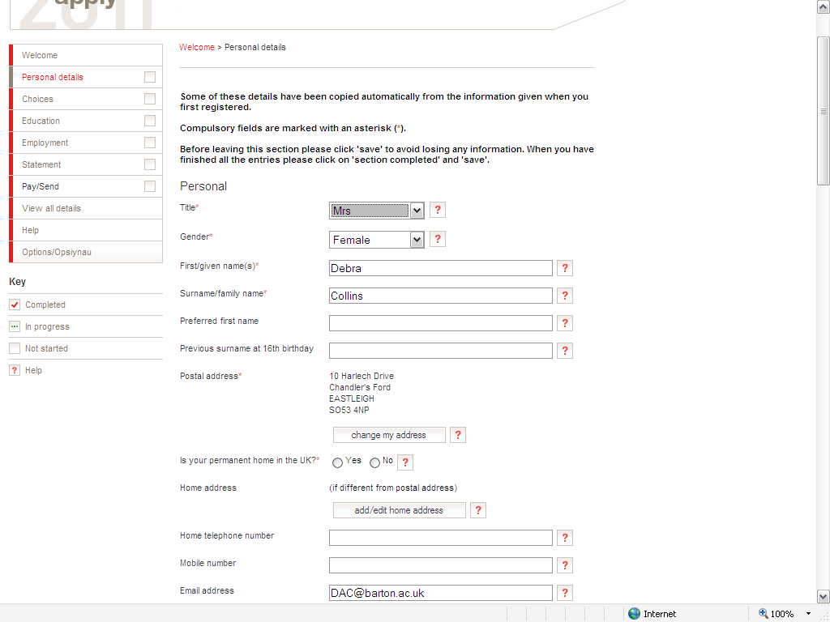
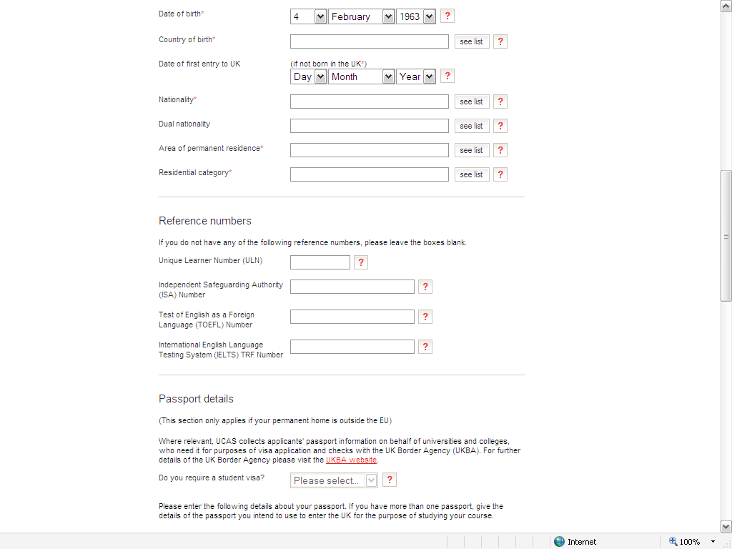
You can see your ULN on Studio. Please let Student Services know if you do not have a Unique Learner Number.

Independent Safeguarding Authority (ISA) Number
If you are applying for courses that involve working with children or vulnerable adults, you must register with the Independent Safeguarding (ISA). If you have already registered with the ISA, please enter your registration number in the box.
You do not have to register before you send your application or before you start your course but you will need to register before you can start a work placement.
If you are not applying for courses that involve working with children or vulnerable adults, please leave the box blank.
For information about ISA, visit www.isa-gov.org.uk.

You do not need to complete the Passport details section as your home will be inside the EU.

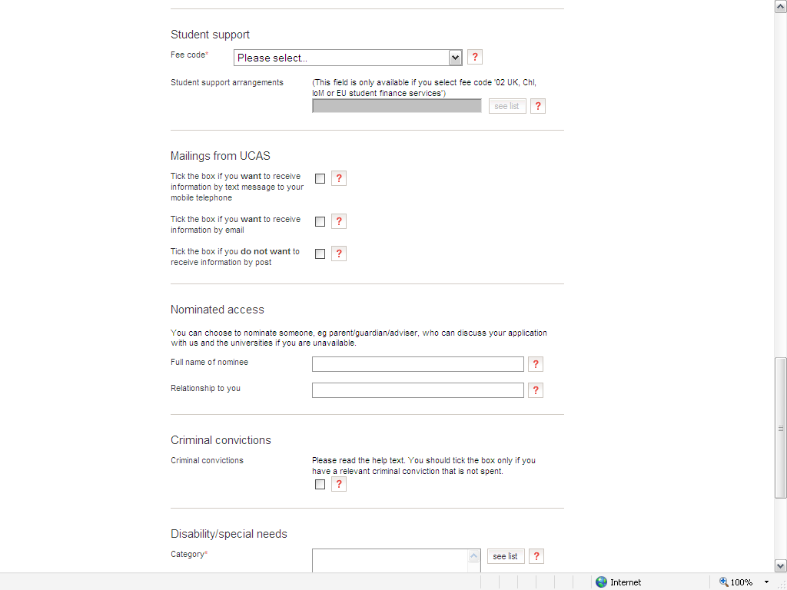
If there is a query with your application and you need to contact UCAS they will only be willing to talk to you as you are the applicant. However if you specify the name of a nominee and their relationship to you in this section UCAS will also be able to discuss your application with this nominated person. This is particularly useful if you are going on holiday or applying for deferred entry as if you nominate your parent or guardian they can follow up queries on your behalf.
STUDENT SUPPORT
The FEE CODE IS 02
(or 05 for Nursing & Midwifery)

Student Support Arrangements:

Use the drop down arrow and choose your local authority for where you live – for Barton Peveril Students this will normally be Hampshire or Southampton

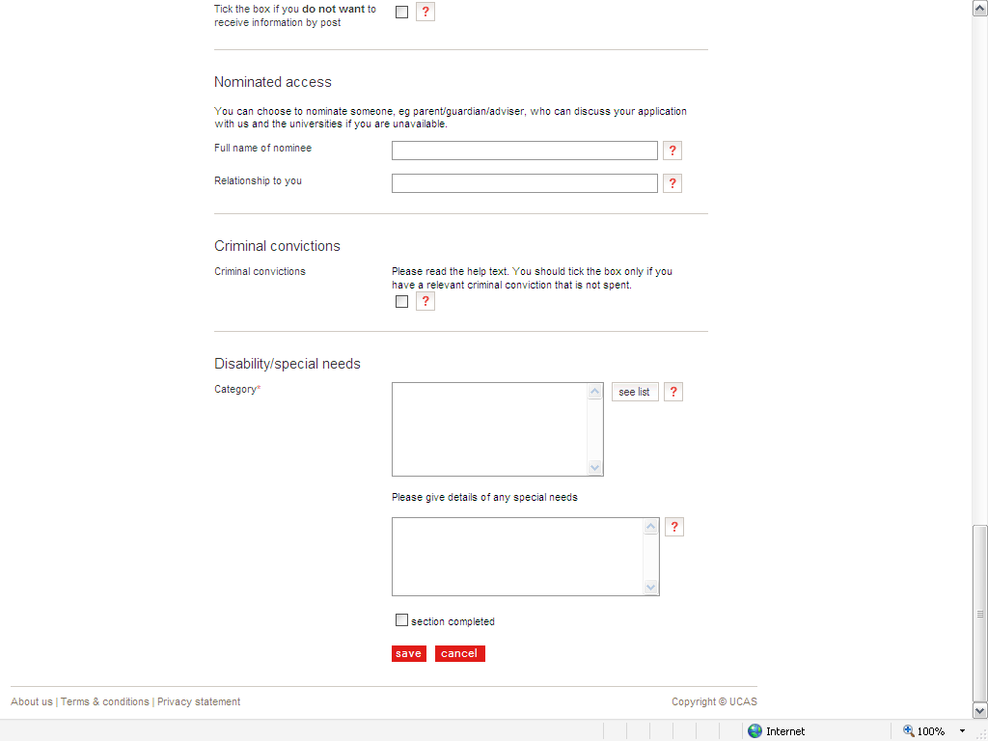
If you have received a conviction, please make sure that you read the help text by clicking on the red ? link.

You must use the drop down list to choose a disability category.

When you have entered all your Personal Details, select ‘section completed’ and then press the red ‘save’ icon.
ADDITIONAL INFORMATION

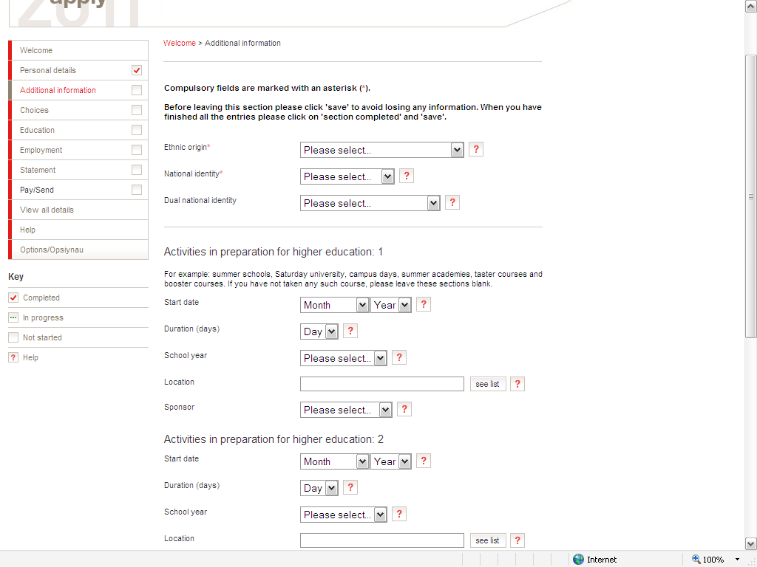
This is where you can enter the details of any courses or summer camps that you have attended as you prepare for university – e.g. Sutton Trust, AimHigher or YG&T Academy events which are held at universities.

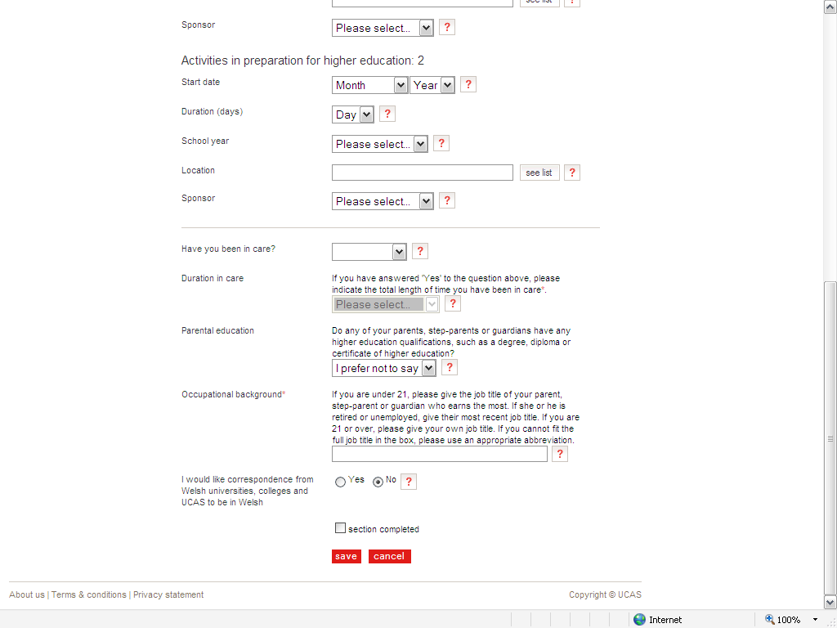

When you have entered all the relevant information click on the ‘section completed’ box and then press the red ‘save’ icon.
CHOICES

In this section you enter the courses and universities/colleges that you are applying to.

Make sure you research thoroughly to ensure you are choosing the best course and university for you!

Attend the university open days.

Aim high but be realistic with your choices – some offers may come back higher than the entry requirements specified on the UCAS website so it is important that you have a ‘safe’ back up option to use as your insurance choice.

Use the Entry Profiles on www.ucas.com to enable you to find out what the entry requirements are so that you can be sure that you are studying the required subjects for your chosen course and that you are on track to gain the grades that the university expects. You will also find out about the course in detail – the content, what makes it different from other courses, special features and opportunities. Compare different courses at different universities – a history degree at Southampton University may have a very different structure to a history degree at Warwick or Bristol!

To find out more about entry profiles log on to www.ucas.com and select the ‘Students’ tab. Then choose ‘before you apply’, ‘what to study’, ‘entry profiles’.

For each choice you will be asked to indicate if you will be living at home or in student accommodation and if you are applying for deferred entry i.e. starting the course in 2012 rather than 2011.

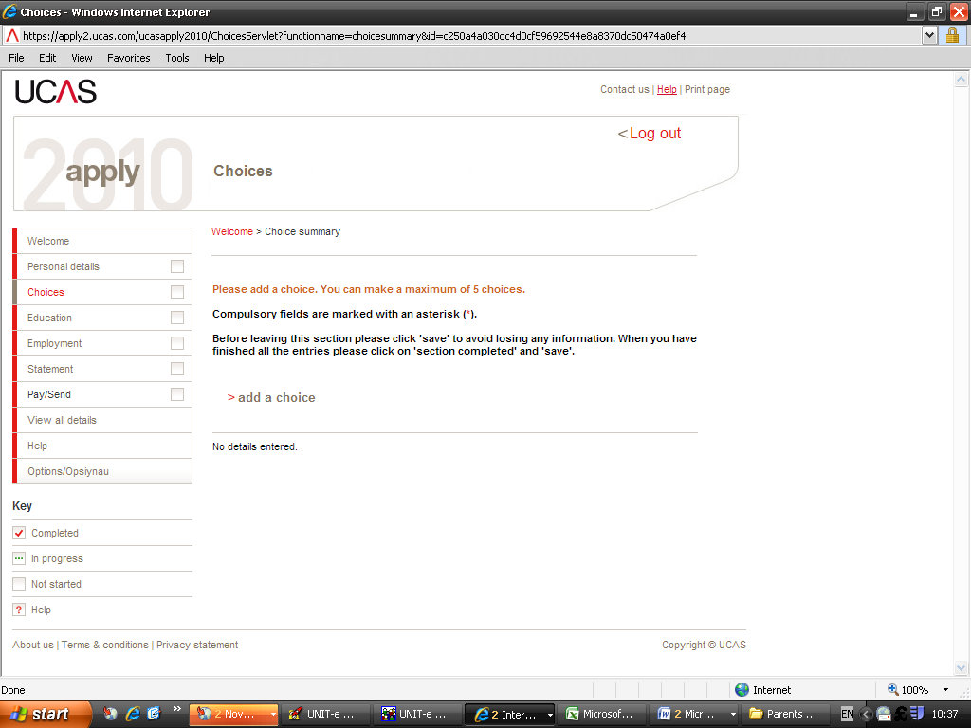

You do not need to select your choices in any order of preference – the UCAS system will put them in alphabetical order on your application.

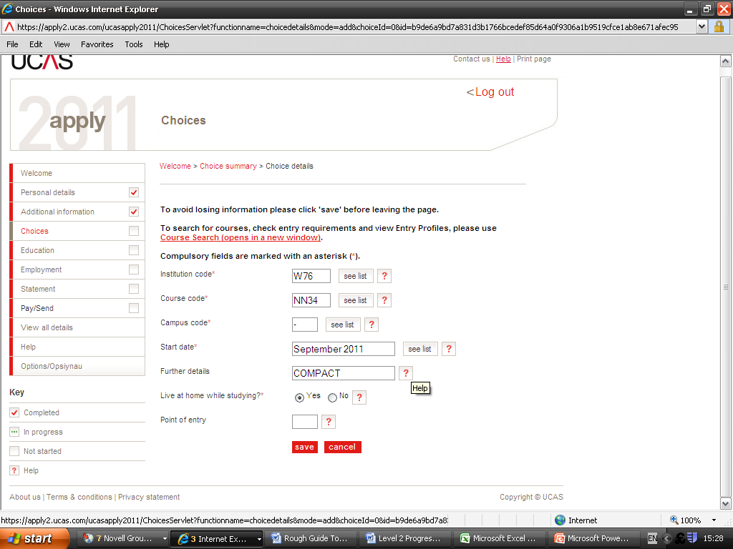
Leave this blank if you are going into the first year of the course.
If you are planning to submit a COMPACT application, note this in the ‘Further Details’ field.

If you are applying for a Progression Agreement, enter HI-PA in the ‘Further Details’ field

After making each choice, click on the red ‘save’ icon.

You can make a maximum of 5 choices.

NB:

You can only apply to Oxford or Cambridge – please note the early internal deadline of 17th September 2010 to ensure applications reach UCAS by 15th October 2010.

You can only apply for up to 4 medicine or dentistry courses – please note the early internal deadline of 17th September 2010 to ensure applications reach UCAS by 15th October 2010.

Education

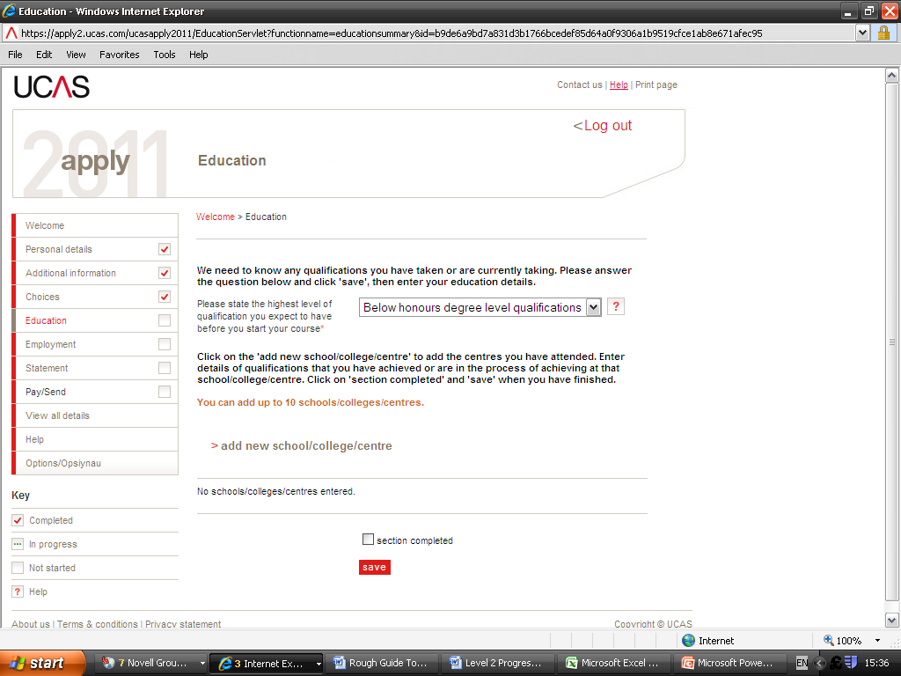
Choose from the drop down list

UCAS need to know where you have studied and which qualifications you are taking/have taken. You will be asked to fill in your school and college details and then list your qualifications. Make sure you have included all relevant qualifications, including any that you have completed and any that you are currently taking.

In addition to GCSEs taken at secondary school and AS/A2 subjects being studied at college you may also have taken Music or Speech and Drama exams and these are also worth UCAS points. You will need to know the centre number for each institution – this will be shown on your exam certificates.

Your tutor will also have a copy of the centre number for your secondary school.

You will also need to know the exam awarding board for each qualification – again you should have this on your exam certificate.

Enter all qualifications that you are currently studying for and add your results as ‘pending’. If you have declined a grade you do not need to put this on your application.

If you are taking a subject through to A2, there is no need to enter it as both AS and A level, just show it on your application once under GCE Advanced Level.

Once you receive your AS results in August, you will be able to update your application for any subject that you have just studied to AS level – select GCE Advanced Subsidiary from the list of qualification types.

Click on the ‘add new school/college’ link to put in your secondary school details and add your GCSE results.

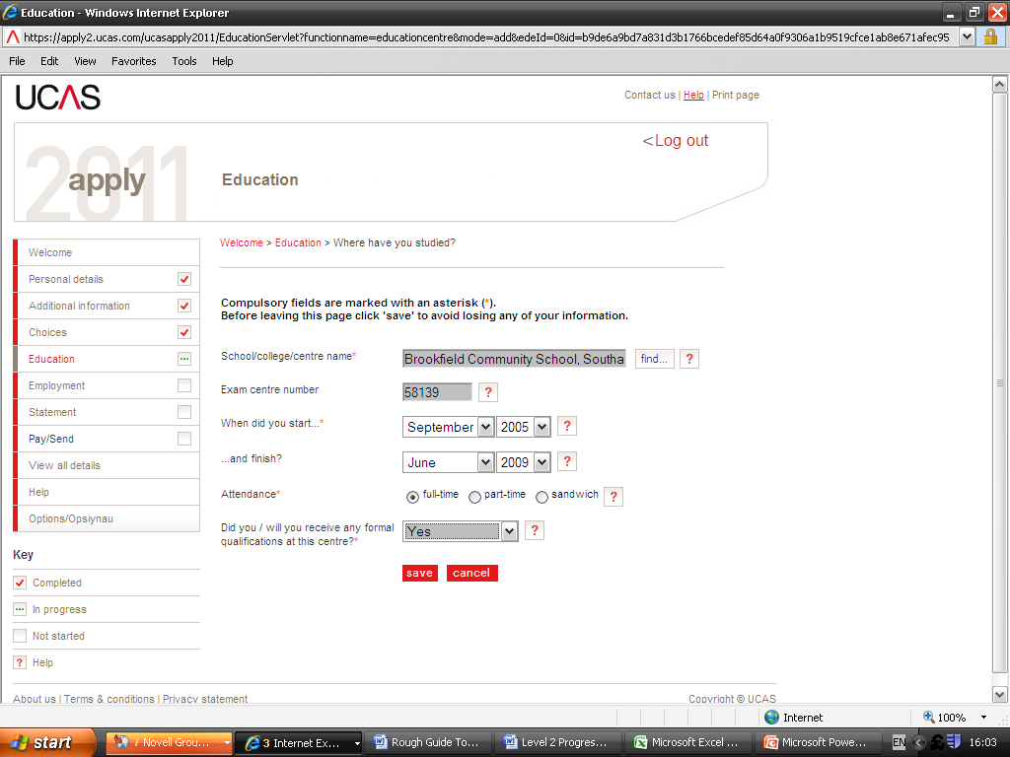
Make sure you enter the correct start and finish dates – this will link to your GCSE qualification and a common mistake is to input the wrong dates which results in an error message.

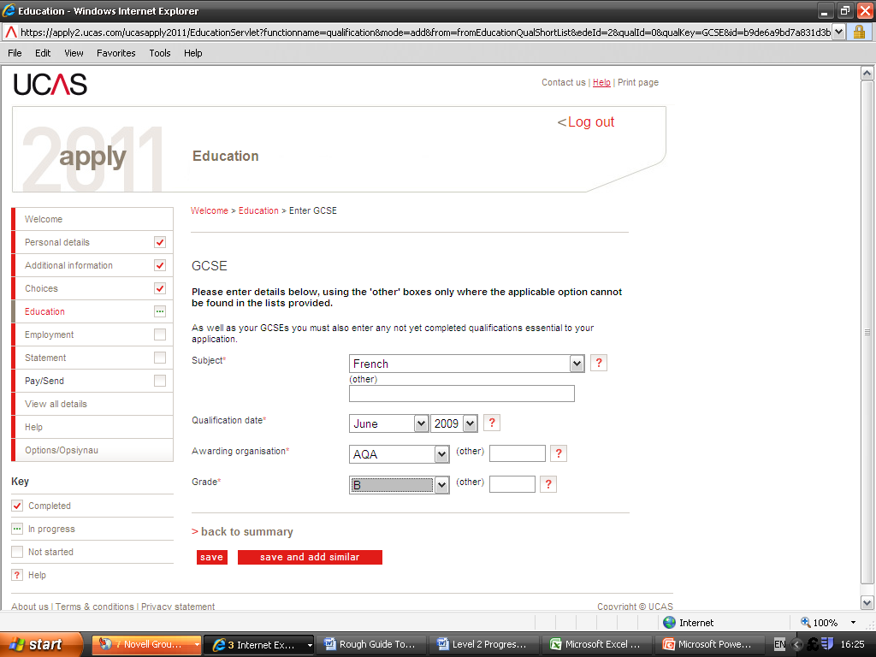
Make sure that you enter the correct date that you took your GCSE exam – this must not be after the finish date specified on the school details.
Make sure that you enter the correct date that you took your GCSE exam – this must not be after the finish date specified on the school details.

When you have entered all the qualifications from secondary school, click on the red ‘save’ icon. You can then add a ‘new/college’ and input your College details, again ensuring that your start and finish dates are correct.

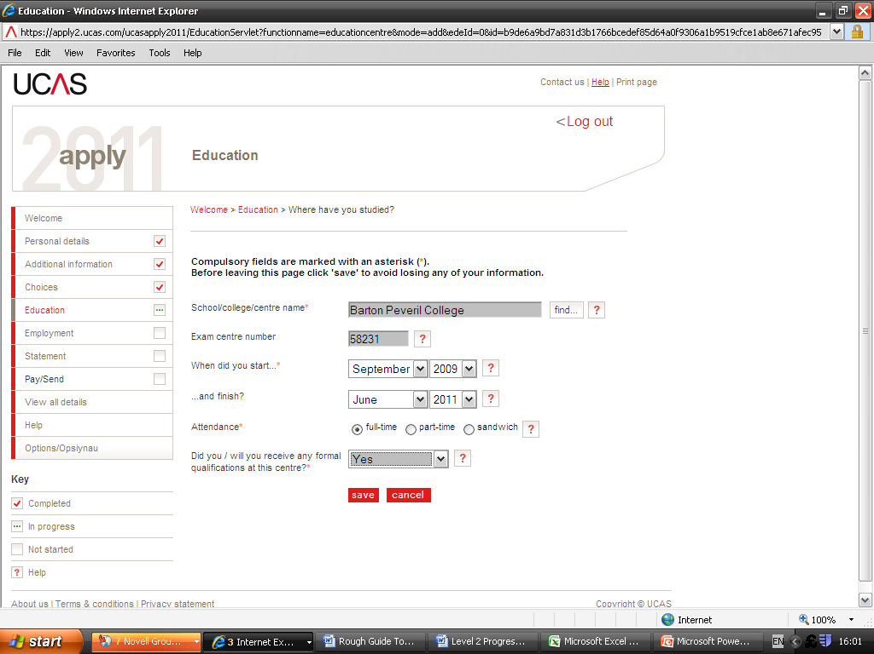

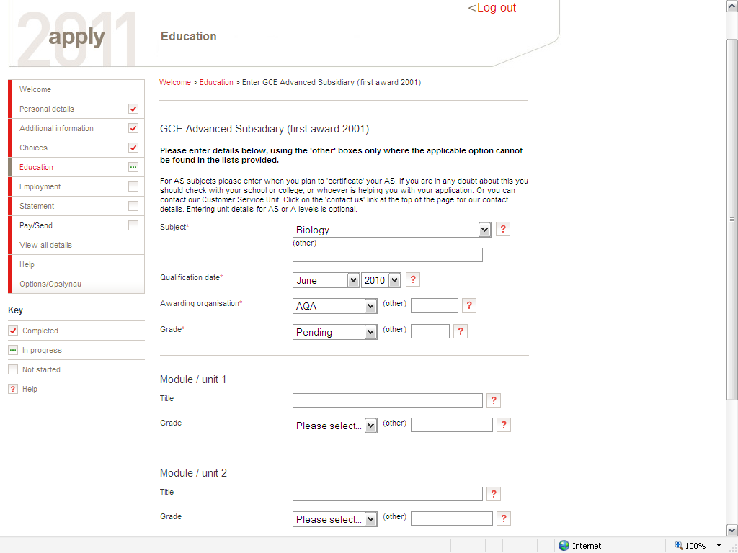
ENTERING MODULE UNITS AND GRADES:

This is optional – it is entirely up to you as the applicant whether you enter your individual modules and grades.

If you have achieved good grades for your modules, then it might be a good idea to include them in your application – especially if a particular module is relevant to the course you are applying for.

If your grades are a bit inconsistent – for example you have achieved good grades for most but one did not go so well, then it may be better not to include them.

College advice would be to either include all of them or none of them to show consistency within your application.

EMPLOYMENT

In this section you fill in the details of your work history and employers. You can add up to 5 employers.

If you have not had any jobs you can leave this section blank, but you will still need to mark it as complete in order to continue with your application.

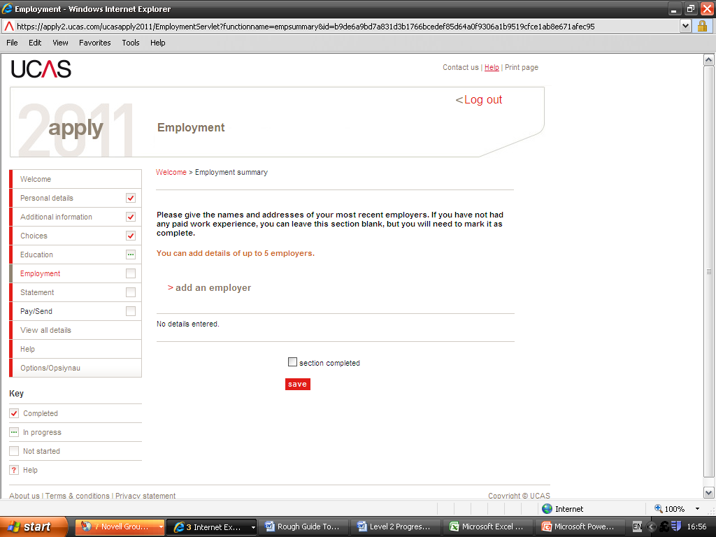

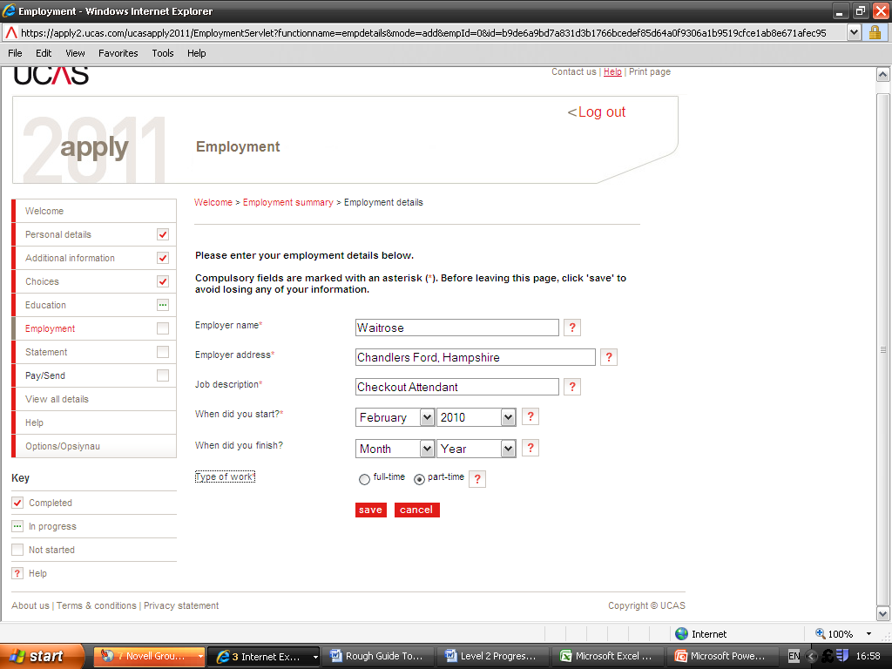
PERSONAL STATEMENT

You need to complete a personal statement which tells your universities or colleges why you are applying for the course(s) you have chosen and why they should want you as a student. This statement helps universities and colleges to know more about you as a person.

You only complete one personal statement and this will be used for each of your university choices.

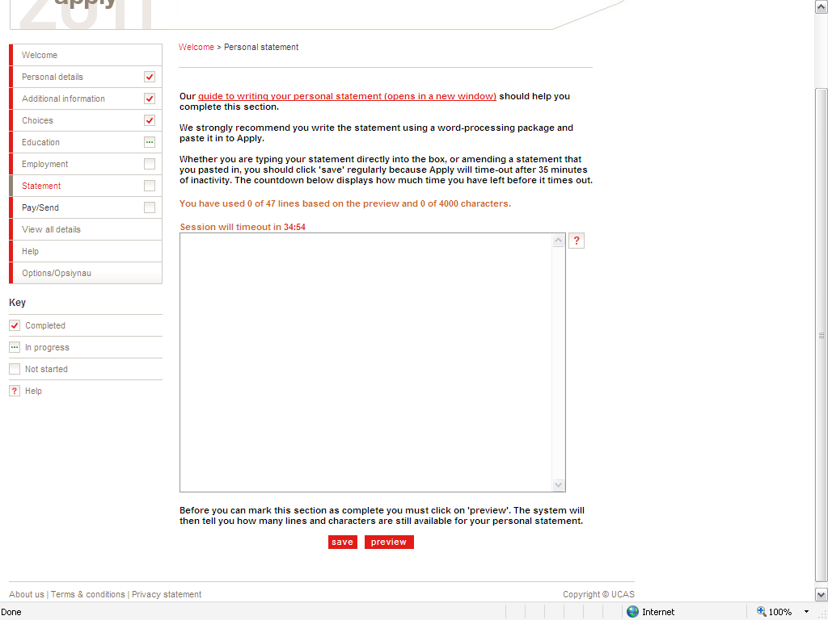
47 LINES/4000 CHARACTERS TO SELL YOURSELF TO THE ADMISSIONS TUTOR – THIS IS YOUR CHANCE TO IMPRESS THEM. THINK OF IT AS YOUR PERSONAL PAPER INTERVIEW!

You will have already received a Personal Statement Writing booklet – refer to it and include as much as you can about yourself.

A good personal statement is very important – few universities actually interview now and the way you write this could persuade an Admissions Tutor to offer you a place.

You must be truthful and your personal statement must be your own work. UCAS have a very complex system in place to check for plagiarism so do not be tempted to use extracts from other people’s statements which may be posted on the internet.

Make sure you mention your involvement in master classes, volunteering, extra curricular activities such as the Duke of Edinburgh award, guiding or drama groups, your sporting achievements and interests and your future plans.

Make reference to the course you are applying for – why do you want to study it and what could you offer to the university. You also need to make your personal statement general enough for each of the universities you are applying to – do not write that you have always wanted to study at Cardiff University when you are also applying to Plymouth and Birmingham!!

Make sure your personal statement is grammatically correct and use spell check!! Admissions Tutors will not be impressed by careless mistakes so take your time and ask other people to read and check it for you. Make sure it is as perfect as it can be!
REFERENCES

UCAS require a reference from your tutor and subject teachers as they know you well enough to write about you and your suitability for the course. Your tutor, Student Progress Manager and Student Services staff will arrange for a reference to be written and attached to your application.

Payment

The cost for applying to one choice is £11.00
The cost for applying for two or more choices is £21.00

Once your tutor has confirmed that your application is ready to be submitted, you pay the application fee online using a credit or debit card by selecting ‘pay/send’ from the menu on the left hand side of the screen when you are logged into your application in APPLY11.

You are unable to pay for your application via Student Services or the College Shop.

After you have done this, your reference will be attached by Barton Peveril and, following a final check, your application is submitted to UCAS.

Once UCAS receive your application it cannot be changed. They will process it, send a copy to each of your chosen universities/colleges and advise you by letter about the next stage of the process.

USE UCAS TV!!

UCAS have introduced lots of new ways to help you research and make your university applications. UCAS is also on Twitter!

Log on to www.ucas.tv

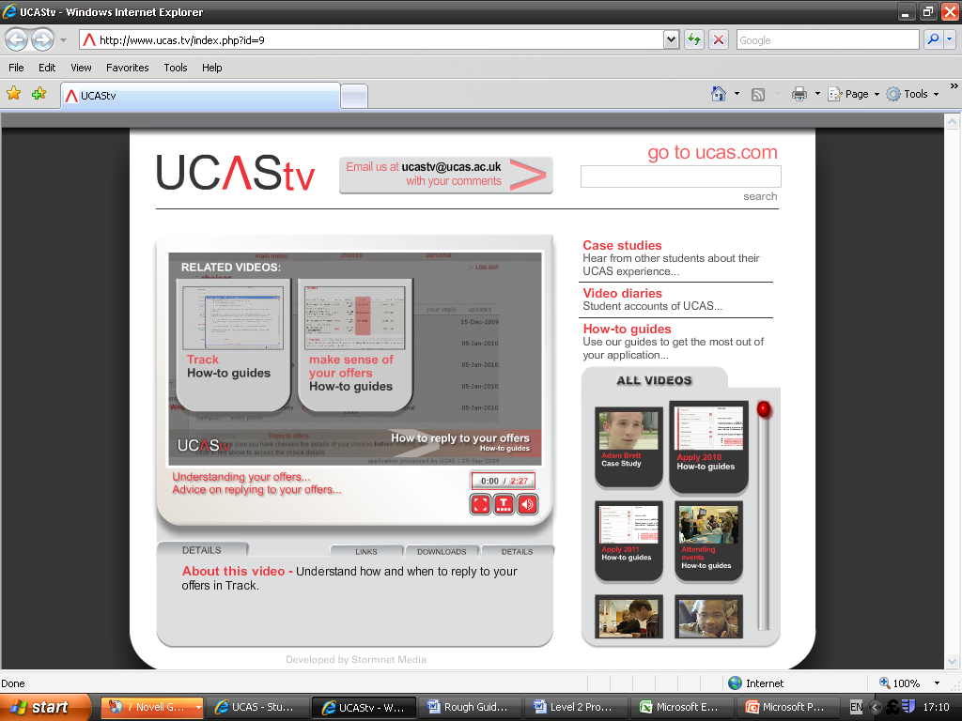
Look at the ‘How To’ guides on UCAS TV

There are ‘How To …..’ guide for:

Registering and logging into Apply

Choosing your courses

Writing your personal statement

Using Track

Making sense of your offers

Replying to offers

Using UCAS Extra

Using Clearing

You can also look at case studies and video diaries and find out useful tips on attending Open Days and HE Events.

COMPACT APPLICATIONS

What is a COMPACT?

Some students may be eligible to apply for a Compact application at certain universities. This means that they may be considered for an offer based on lower entry requirements or receive a specific bursary. For 2011 entry we have the following agreements:

Chichester University
Winchester University
Solent University
Southampton University Access 2 Southampton Scheme

If you are intending to make a Compact Application, you need to note this on your UCAS application by typing ‘COMPACT’ in the Further Details field in the Choices Section.

Generally you will need to fulfil 2 of the criteria to be eligible for a Compact scheme.

Chichester University Criteria for 2011 entry:

If you are applying to Chichester University and you have successfully completed, or are expected to complete, a relevant Level 3 course then you will be guaranteed a standard offer or an interview for a place at Chichester as long as you meet the application deadline and also meet or be predicted to meet the entry requirements.

Special consideration will be given to students whose academic attainment may have been affected by at least 2 mitigating circumstances listed below:

First in family to undertake HE
Has had a disrupted pattern of education
Has experienced difficult family circumstances
Has had caring responsibilities
Is in receipt of EMA
Has attended a school which achieved less than 60% 5 A*-C passes at GCSE

Winchester University Criteria for 2011 entry

First in family to undertake HE
Difficult financial circumstances
Problems relating to health, disability or bereavement
Caring responsibilities
Has been in the care of the local authority
Has had a disrupted pattern of education
Is from a group which is under-represented in HE

Solent University Criteria for 2011 entry

Long-term illness
Disability
Bereavement
Difficult Family circumstances
Caring for a sick or disabled relative
Having responsibility for younger siblings
Having responsibility for a baby - single parent
Being in care
In receipt of an Educational Maintenance Allowance (EMA) at the rate of £30 or £20 per week
Coming from a low-income family
Having attended a school which achieved less than 60% 5 A*-C passes at GCSE
Having attended a secondary school which does not have a strong tradition of post-16 or post-18 progression
‘Please note colleges can recommend a student if they fit one or more of the above criteria. A letter of support explaining in detail their circumstances would be required and in some cases supporting evidence as well for example official documents where applicable.’

Southampton University

Southampton launched their Access 2 Southampton Scheme in 2009.

Students who are applying to Southampton University for 2010 entry and who are interested in the A2S Scheme should have already attended a meeting with Nicola Peacock here in College and already completed an application form. The deadline for this Scheme was 22nd May 2010.

Booklets giving full details of the Scheme can be collected from the Student Help Desk.

What is Access to Southampton?
The University of Southampton recognise that exam grades do not always reflect what a student is capable of achieving. Our scheme gives some students who have experienced difficulties or hardship an opportunity to realise their potential. Access to Southampton (A2S) aims to assist those talented students capable of studying at the University of Southampton through a pre-University entry scheme. Access to Southampton is the University of Southampton's alternative entry scheme offering special consideration to applicants from educationally, financially or socially disadvantaged backgrounds. Applications are welcomed from students who meet the eligibility criteria (below) and have the potential to study at the University of Southampton:

How does it work?
All Access to Southampton applicants will receive special consideration from University of Southampton admissions tutors because of their individual circumstances. However, the Access to Southampton scheme does not guarantee an offer from the University, admissions decisions will be made on a combination of the applicants’ predicted grades, content of their UCAS personal statement, UCAS reference, interview (for some courses), and the additional information provided by the applicant and teacher on the Access to Southampton application form.
Successful applicants will receive two offers, the standard offer as published in the University prospectus, and the alternative Access to Southampton offer, two grades lower than the standard offer. The Access to Southampton alternative offer is conditional, and requires the applicant to attend a three day assessed Summer University (July 2010) and a two day 'Get Ready to Go' event at Easter 2011. Applicants have to make the University of Southampton their conditional firm choice when applying to UCAS, to remain eligible for the alternative Access to Southampton offer.

What subjects are available?
Archaeology
Chemistry
English
Geography
History
Law
Music
Nursing: Mental Health Nursing
Nursing: Learning Disability Nursing
Nursing: Children’s Nursing
Nursing: Adult Nursing
Politics
Psychology
Social Sciences: Sociology
Social Sciences: Sociology & Social Policy
Social Sciences: Applied – General Pathway
Social Sciences: Applied – Anthropology
Social Sciences: Applied – Criminology
Social Science: Applied – Criminology & Psychological Studies

What do I have to achieve?
If you are accepted onto the A2S scheme, you must attend:
a three-day, non-residential, Assessed Summer School
a two-day, non-residential, Academic Study Skills School
All applicants will be expected to complete two forms of assessment at these events.

Eligibility
To apply for the scheme, Year 12 students studying at Hampshire or Isle of Wight FE Colleges / Sixth Forms must meet at least two of the following criteria:

Be in receipt of an Educational Maintenance Allowance (EMA) of £20 or £30 a week
Be in the first generation of immediate family to apply to Higher Education
Have attended a secondary school which achieved less than 48% 5 A to C passes (including English and Maths) at GCSE in 2008
Only option is to attend a local University
Studies disrupted by circumstances in their personal, social or domestic life
Living or grew up in public care

How do I apply?
Collect a College Compact Application form and an Access to Southampton application form from Student Services. You will need a copy of your UCAS application and a reference from your tutor.

What happens on the A2S?

If the A2S application is successful we will make a scheme offer with a lower A level target (or equivalent qualification) in most cases, so students will be made an offer as set out in the Prospectus, and a separate alternative offer (the A2B offer). The scheme offer will typically amount to a reduction of up to two A-level grades (e.g. BCC rather than BBB) together with satisfactory completion of the Assessed Summer University and the A2S Study Skills. It is important to stress here that a two grade reduction in the offer from the University is not guaranteed.

Students who wish to apply under the Compact Scheme should complete a Compact application form (available from Student Services) and return it – with a printed copy of their UCAS application form – to Debra Collins in Student Services.

We are also able to send off a letter of support for any student who may have ‘special circumstances’.

If any further information about Compact Arrangements for 2011 entry is received it will be circulated.
BARTON PEVERIL COLLEGE
COMPACT APPLICATION 2011 ENTRY

Surname: |  | Forename(s):
Date of Birth: |  | Gender:
Tutor Group: | Tutor: |  | Student Progress Manager:
Home Address:

Home Telephone No: |  | Mobile No:
Email Address:

Current Subjects
Grades already achieved for AS Levels

Please indicate the University you are applying to | Solent  Southampton  Winchester  Chichester
Please indicate the course you are applying for

UCAS Application Number (available once you have submitted and paid UCAS) | 10-

Please note the reasons you are completing a Compact Application – anything you write here will be confidential and only released to the University chosen above. Continue overleaf if necessary.

PROGRESSION AGREEMENTS

What is a Progression Agreement?

A Progression Agreement guarantees you a place in the selection process, an interview or offer of a place on a course related to your qualifications and/or experience.

The Hampshire & Isle of Wight Lifelong Learning Network has the following Agreements for Barton Peveril Students:

SOUTHAMPTON SOLENT UNIVERSITY

Listed below are routes with guarantees attached from A2 MUSIC.

Course | Agreement
BA (Hons) Popular Music and Record Production | Guaranteed Interview
BA (Hons) Popular Music Music Studies | Guaranteed Interview
BA (Hons) Urban and Electronic Music | Guaranteed Offer
BA (Hons) Music Promotion | Guaranteed Interview
BA (Hons) Music Radio | Guaranteed Interview
BA (Hons) Popular Music Journalism | Guaranteed Offer

PORTSMOUTH UNIVERSITY

Listed below are routes with guarantees attached from A2 MUSIC.

Course | Agreement
BSc(Hons) Music and Sound Technology | Guaranteed Offer

SOUTHAMPTON SOLENT UNIVERSITY

Listed below are routes with guarantees attached from A2 MUSIC TECHNOLOGY.

Course | Agreement
BA (Hons) Popular Music and Record Production | Guaranteed Interview
BA (Hons) Popular Music Music Studies | Guaranteed Interview
BA (Hons) Urban and Electronic Music | Guaranteed Offer
BA (Hons) Music Promotion | Guaranteed Interview
BA (Hons) Music Radio | Guaranteed Interview
BA (Hons) Popular Music Journalism | Guaranteed Interview

PORTSMOUTH UNIVERSITY

Listed below are routes with guarantees attached from A2 MUSIC TECHNOLOGY.

Course | Agreement
BSc(Hons) Music and Sound Technology | Guaranteed Offer
UCAS 2010 TARIFF POINTS

 | Grade A* | Grade A | Grade B | Grade C | Grade D | Grade E
GCE A2 Level | 140 | 120 | 100 | 80 | 60 | 40
GCE AS Level |  | 60 | 50 | 40 | 30 | 20
If the student achieves an AS and A2 in the same subject, only the points from the A2 level can be counted.

 | DISTINCTION | MERIT | PASS
OCR Nat Cert (6 units) | 120 | 80 | 40
 | DISTINCTION | MERIT | PASS
OCR Nat Dip (12 units) | 240 | M1 = 200  M2 = 160 | P1 = 160  P2 = 120  P3 = 80

 | DISTINCTION | MERIT | PASS
BTEC National Award (6 units) | 120 | 80 | 40

Key Skills | Some universities will include key skills points, others will not. Where they are counted, each Level 3 pass will score 20 points and each Level 2 pass may score 10 points.

Music Exams | DISTINCTION | MERIT | PASS
Grade 8 Practical | 75 | 70 | 55
Grade 7 Practical | 60 | 55 | 40
Grade 6 Practical | 45 | 40 | 25
Grade 8 Theory | 30 | 25 | 20
Grade 7 Theory | 20 | 15 | 10
Grade 6 Theory | 15 | 10 | 5
Points are for ABRSM, Guildhall, LCM, Rockschool and Trinity exams.
Speech & Drama Exams | DISTINCTION | MERIT | PASS
PCertLAM | 90 | 80 | 60
Grade 8 | 65 | 60 | 45
Grade 7 | 55 | 50 | 35
Grade 6 | 40 | 35 | 20
LAMDA, LCM and Trinity Guildhall Exams from 2008 entry.
LAMDA Level 3 Certificate in Speech and Drama Performance Studies (PCertLAM).
Contacting UCAS

If you have any queries following the submission of your application to UCAS, you can contact them at:
Rosehill
New Barn Lane
Cheltenham
Gloucestershire
GL52 3LZ
Telephone: 0871 4680468

Student Services Staff
Your Tutor will help you with your UCAS application, but the staff in Student Services are also available to give you further support.
Please feel free to contact us at any time by e-mail, or alternatively you are welcome to come and see anyone in the Team between 12.35pm and 2.00pm, Monday to Friday for UCAS queries.
Anne Platt Student Services Team Leader: AEP@barton.ac.uk
Sarah Moorman Student Services Administrator SHM@barton.ac.uk
Steve Hodge Student Services Administrator SQH@barton.ac.uk
Deb Collins Student Services Manager DAC@barton.ac.uk

APPLYING FOR HE FINANCE
We will arrange for HE Finance presentations to take place during Tutor Time in the Autumn Term as you should be able to apply for your loans and grants in October/November (dates to be confirmed by Student Finance England).
We will also be holding meetings for parents about how students apply for their HE Finance – dates to be confirmed.
You will receive a booklet from Student Finance England as soon as they are available which gives further information.

Going to university/college?
Do you know when?
Find out.
www.opendays.com
Open day details for universities and colleges all over
England, Scotland, Wales, Northern Ireland, New Zealand and Australia
Open day dates, booking and travel details, contact information and links to the institution’s websites
Open day calendars, advice on how to get the most out of open days and how to decide where to go

Please note that you often need to book a place on an Open Day – you can’t just turn up! Sometimes places will be limited so please visit this website regularly and book your place early to ensure availability!

